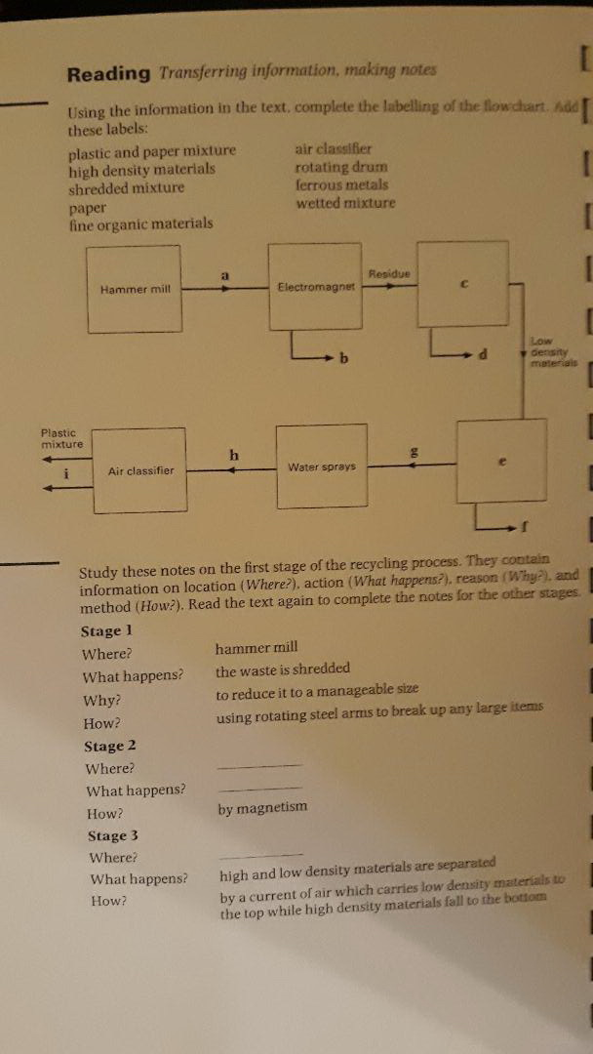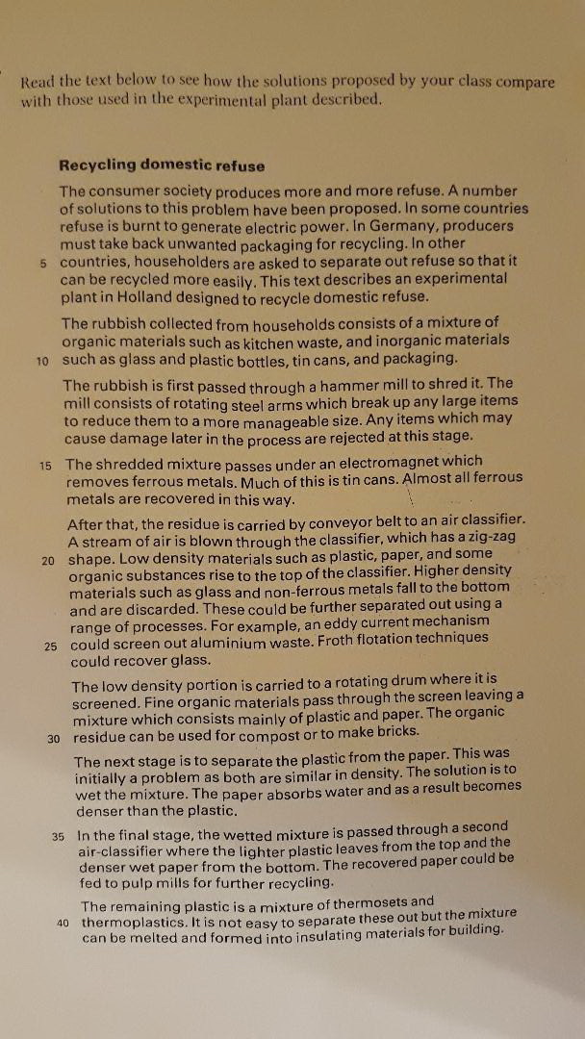
I First read the text on Recycling domestic refuse and then do the exercises on the first page.
Additional task: Watch one episode of How it is made? on the Youtube channel,
and then try to summarize the industrial processes you have seen there in one
paragraph by using your own words!

